GGR272 Assignment 1



<https://www.esri.com/news/arcuser/0499/umbrella.html>

The organization that created the webpage is Esri.

The web page discusses benefits of GIS in the health care industry. It can be used to track sources of diseases and a famous example of this is a doctor named John Snow mapping the locations of the affected areas to find the source of the cholera epidemic in London. GIS can also be used to keep records of immunizations and move data to be used by an entire organization. This allows for quick access to medical records which is a huge bonus. In the private health sector, GIS can be used to determine the needs of residents in a particular area to help practicing physicians determine the ideal location to open their practices.

I chose this web page because I am interested in how GIS can be used for Public Health. I am a fourth year statistics student with an interest in biostatistics and epidemiology so I wanted to learn more about tools that I can use in this area. I have some knowledge of using other software with health care data, particularly the R programming language and I wanted to learn more about how GIS could be used instead of R in certain situations. I also had no idea that GIS was used in the private health sector so I learned something new.

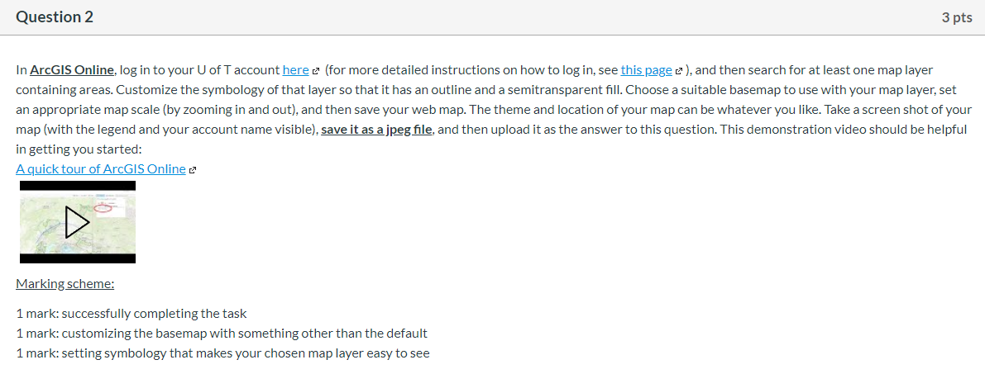

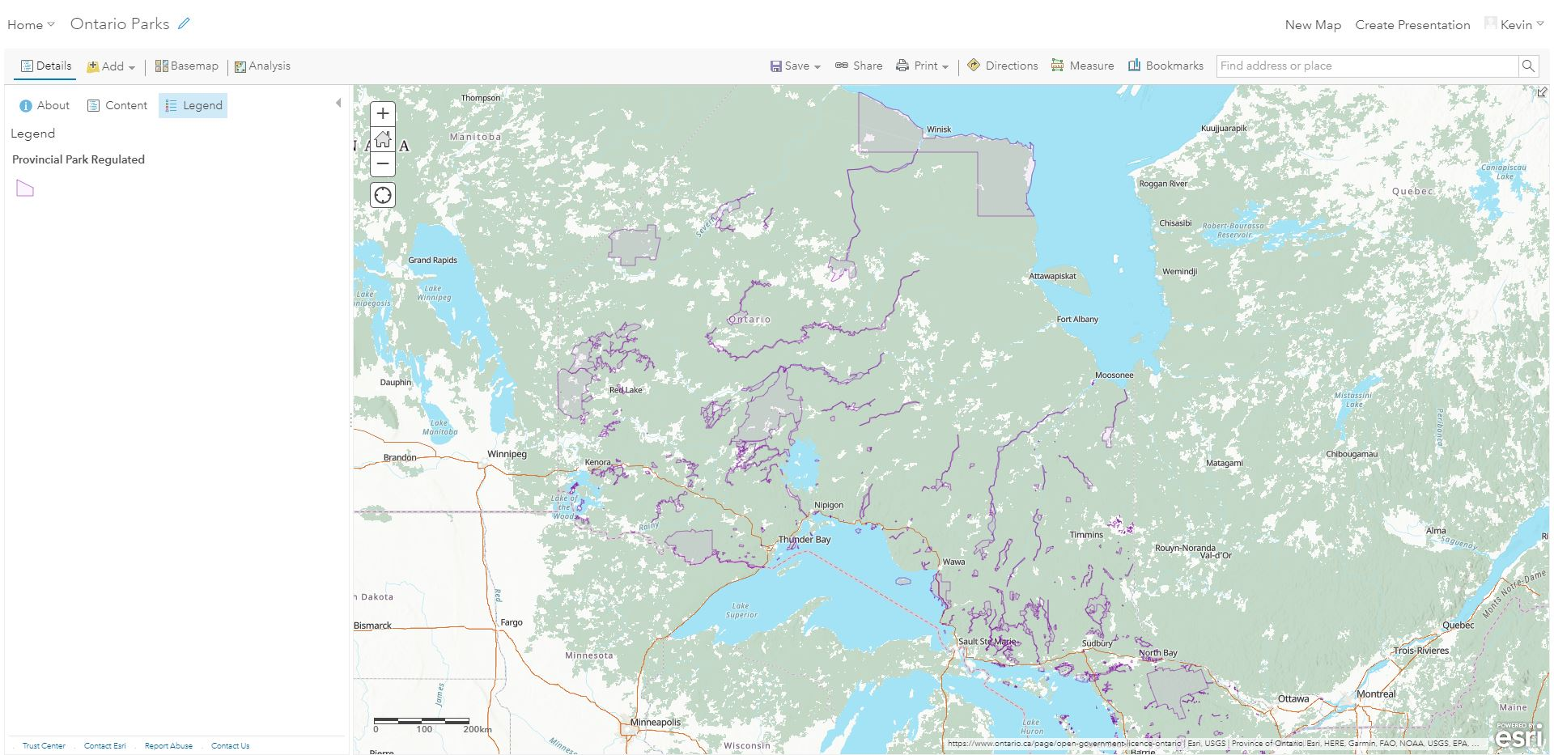

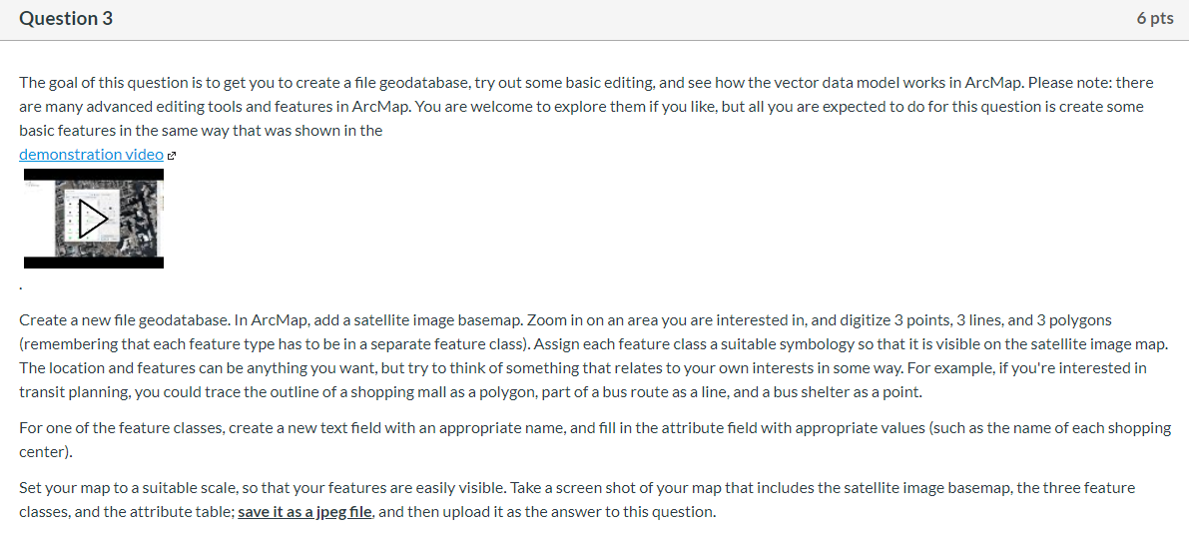

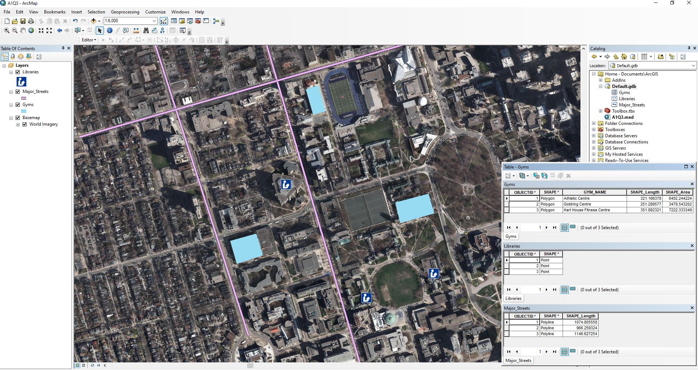

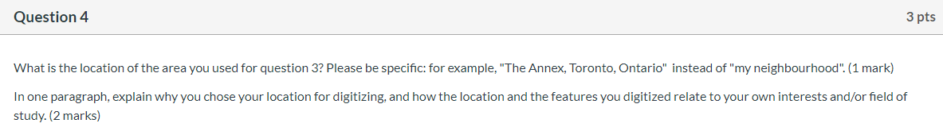

The location of the area used in question 3 is the University of Toronto St. George Campus, Toronto, Ontario, Canada.

I chose this location because it is where I spend most of my time while awake. I chose to digitize the three gyms as polygons because I have been training with a dragon boat team at the three gyms (Athletic Centre, Goldring, Hart House) on a regular basis. I also digitized three libraries (Robarts, Gerstein, Caven at Knox College) where I usually go to study as points. Last but not least, I represented three major streets (Spadina, St. George, Bloor) as lines since I find myself walking on at least one of them every time I’m on campus.